**Experiment 3**

**Shashwat Tripathi**

**D15A Batch C  
Roll No: 64**

**AIM : To include icons, images, fonts in Flutter app  
  
THEORY & Code :   
  
OUTPUT :**

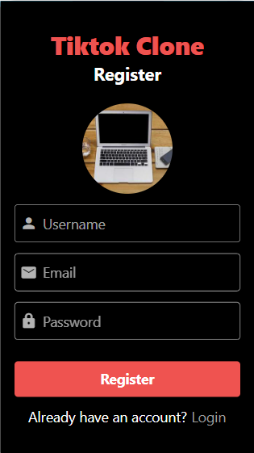

**CONCLUSION :**